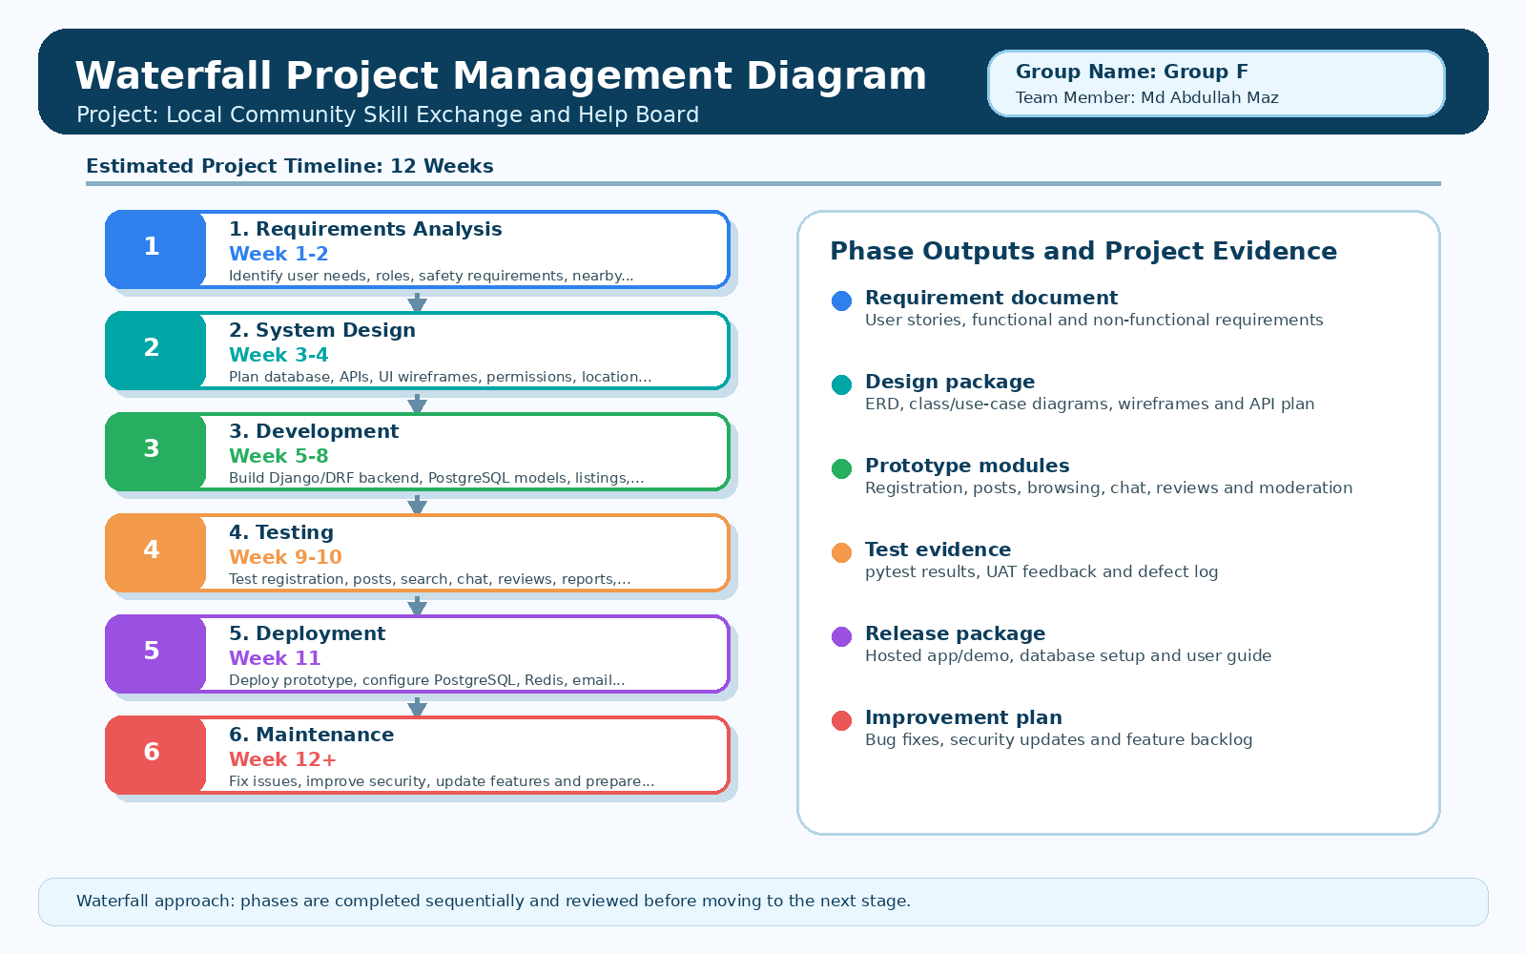
Figure 1: Waterfall Project Management Diagram for Local Community Skill Exchange and Help Board

